**Health factor formula**

Let

* *TB* be the total borrowed amount in USD $.
* *CA* be an array of collateral amounts in USD $.
* *TA* be an array of threshold values.

Then, the function calculateHealthFactor can be represented as:

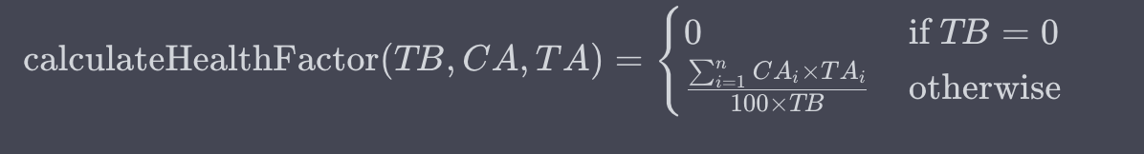

Where:

*n* is the number of elements in the arrays CA and TA.

CA-(i) is the I-th element in the array of collateral amounts.

TA-(i) is the I-th element in the array of threshold values.

Please note that this formula assumes that TB,CA-(I) and TA -(i) are in $.

**LiquidationThreshold Formula**

Let

* *TC* be the total collateral amount in USD $.
* *CA* be an array of collateral amounts in USD $.
* *TA* be an array of threshold values.

Then, the function calculate Liquidation threshold can be represented as:

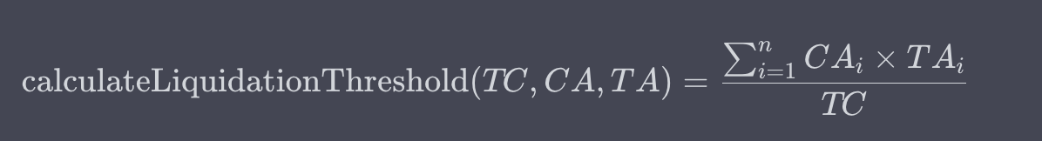

Where:

*n* is the number of elements in the arrays CA and TA.

CA-(i) is the I-th element in the array of collateral amounts.

TA-(i) is the I-th element in the array of threshold values.

**Net Asset Value Formula**

Certainly! Here's the mathematical representation of the `calculateNAV` function:

Let:

- TVA be the total value of assets.

- TD be the total debt.

Then, the function `calculate Net Asset Value:` can be represented as:

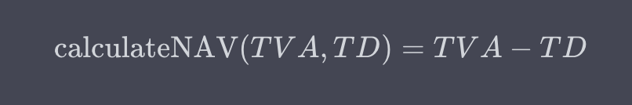

Where:

- TVA is the total value of assets.

- TD is the total debt.

This formula assumes that both TVA and TD are expressed in the same unit of value (e.g., dollars, euros, etc.). If they are in different units, make sure to adjust the formula accordingly.

**Current Loan to Value Formula**

Let:

- OLA be the outstanding loan amount.

- CV be the collateral value.

Then, the function `calculate Current Loan to Value` can be represented as:



Where:

- OLA is the outstanding loan amount.

- CV is the collateral value.

This formula calculates the Current Loan to Value (LTV) ratio as a percentage. Make sure that both OLA and CV are expressed in the same unit of value (e.g., dollars, euros, etc.). If they are in different units, adjust the formula accordingly.

**Utilized Borrowing Power Formula**

Certainly! Here's the mathematical representation of the `utilizedBorrowingPower` function:

Let:

- VB be the total value of borrow assets (alreadyBorrowed+available Borrow Amount)

- VBa be the total value of borrowed assets (alreadyBorrowed).

Then, the function `utilizedBorrowingPower` can be represented as:



Where:

- VB be the total value of borrow assets (alreadyBorrowed+available Borrow Amount)

- VBa be the total value of borrowed assets (alreadyBorrowed).

This formula calculates the Utilized Borrowing Power as a percentage. Make sure that both VB and VBa are expressed in the same unit of value (e.g., dollars, euros, etc.). If they are in different units, adjust the formula accordingly.

**Available To Borrow Formula**

Let:

- CB be the collateral balance.

- LTV be the loan-to-value ratio (in percentage form).

- TBA be the total borrowed amount.

Then, the function `calculateAvailableToBorrow` can be represented as:



Where:

- CB is the collateral balance.

- LTV is the loan-to-value ratio (in percentage form).

- TBA is the total borrowed amount.

This formula calculates the available amount that the user can borrow based on their collateral balance, the specified loan-to-value ratio, and the total amount already borrowed. Make sure that CB and TBA are expressed in the same unit of value (e.g., dollars, euros, etc.). If they are in different units, adjust the formula accordingly.

**How these things achieved by above mentioned formulas -**

* Value eligible for Liquidation
* Wallets eligible for Liquidation
* Value at Risk for Liquidation
* Wallets at Risk for Liquidation

1. **Value eligible for Liquidation**: - This typically refers to the total value of assets that are eligible to be liquidated in case a borrower's collateral falls below a certain threshold. It's calculated based on the collateral's value and the liquidation threshold.

In terms of the formulas provided, this can be calculated using the **calculateLiquidationThreshold** function formula with Health factor formula -

1. **Wallets eligible for Liquidation**: - This refers to the number of individual accounts or wallets that are eligible to be liquidated. Each wallet may have different collateral and debt amounts.

The number of wallets eligible for liquidation can be determined by analyzing the individual wallets' collateral and debt levels and comparing them against the liquidation threshold.

1. **Value at Risk for Liquidation**: - This is the total value that is at risk of being lost in case of liquidation. It's the sum of the outstanding debt that might be recovered through liquidation.

In terms of the formulas provided, this can be calculated using the calculateAvailableToBorrow function:

**Value at Risk for Liquidation=calculateAvailableToBorrow(collateralBalance,ltvRatio,totalBorrowedAmount)**

1. **Wallets at Risk for Liquidation**: - This refers to the number of individual accounts or wallets that are currently at risk of being liquidated. This would depend on their current collateral value, outstanding debt, and the liquidation threshold.

The number of wallets at risk for liquidation can be determined by analyzing the individual wallets' collateral, debt, and comparing them against the liquidation threshold.

**NOTE - These terms and calculations are commonly used in decentralized finance (DeFi) and lending protocols to manage risk and ensure the stability of lending platforms. Keep in mind that the exact definitions and implementations may vary depending on the specific platform or protocol you are working with.**